**We have Two Panel**

1. **DLT Panel (**[**https://smartping.live/**](https://smartping.live/)**) Helpline No: 18001370011**
2. **SMS Panel (**[**https://www.smsgatewayhub.com/**](https://www.smsgatewayhub.com/)**) Helpline No: 9907922122**

**Firstly we have to setup DLT Panel**

**Two major part in DLT panel Setup**

1. **Header Approval**
2. **Template Approval**

**Brief about Header Approval:**

1. **Header must be similar as company name or username**

**1. (if we want to keep the header name of another company name then we have to provide a document to DLT company and we have to show that both companies are the same or related).**

**2. For Example : if our Company name is J P SAFTEK SYSTEMS then we can create header like this : JPSCRM, SAFTEK, JPABCD something like this.**

1. **Header Must be 6 Digit because some sms panel not support 4 or 5 digits.**

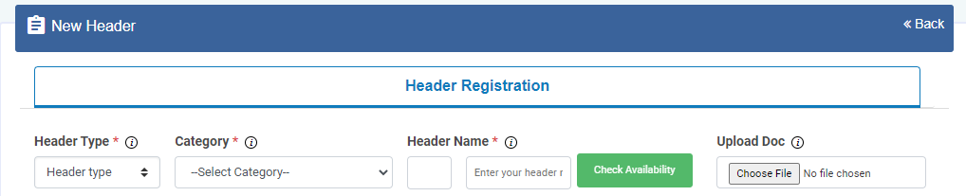

**In this screenshot there are some options are mandatory like:**

1. **Header type:**
   1. **There are two option we have to select “other”**
2. **Category:**
   1. **There are many dropdown option we have to select “Consumer goods and automobiles” because we working on CRM**
3. **Header Name:**
   1. **Header name must be like company name e.g JPSCRM, SAFTEK, JPABCD etc.**



**Check this Screenshot there are examples of how to create a new header. You can also check before creating header name that your header is available or not which you are creating.**

**After submit wait for header approval**

**Brief about Template Approval:**

**Go to template and click “Add New Template”**

**Check this screenshot that what we have to fill this!**

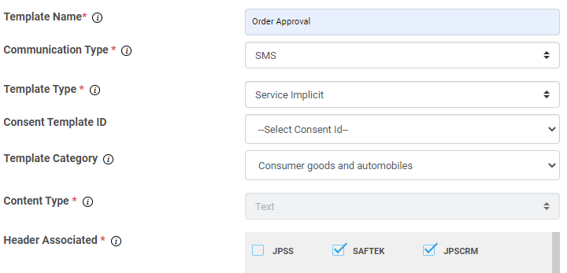

**Descriptions:**

1. **Template Name : Set Template name which should be similar to your purpose of message**
2. **Communication Type : There are only one option then we select “SMS”**
3. **Template Type : There are many option but we have to select “service implicit“**
4. **Consent Template ID : This field in not mandatory so we can leave this option**
5. **Template Category : This is also not mandatory but we can select “Consumer goods and automobiles”;**
6. **Content type : This is a mandatory field but it is auto fetched by system. We are nothing to do in this**
7. **Header Associated : They are showing all Headers which I have created. We can choose any one or all. As per the requirement**

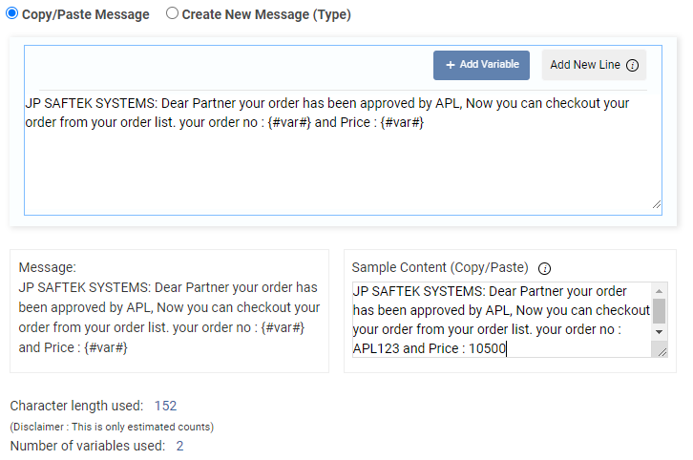

**There are two option.**

1. **Copy/Paste Message** 
   1. **We can copy message from the outside text editor(Notepad or other Text Editor) and paste here.**
   2. **Use {#var#} for creating variable value.**
2. **Create New Message (Type)**
   1. **Here we have to write the message which we want to send the message**
   2. **For using variable we have to click “Add Variable” button**

**There are two more boxes below this main message box.**

1. **Message:**
   1. **We have nothing to do in this. When we type or copy/paste message in above main message box then it automatically reflect here**
2. **Sample Content (Copy/Paste):**
   1. **Which message we have type to the main message box, same message paste here without any changes. Only we have to change the value instead of the variable. Which is showing in above screenshot**

**After Done This Click Submit and waiting for approval**

**Now we have another Panel That is SMS PANEL**

**Login Url :** [**https://www.smsgatewayhub.com/Account/Login**](https://www.smsgatewayhub.com/Account/Login)

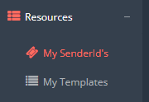

**After Login Click “My Senderid’s” in “Resources” menu**

**There will open page like this:**

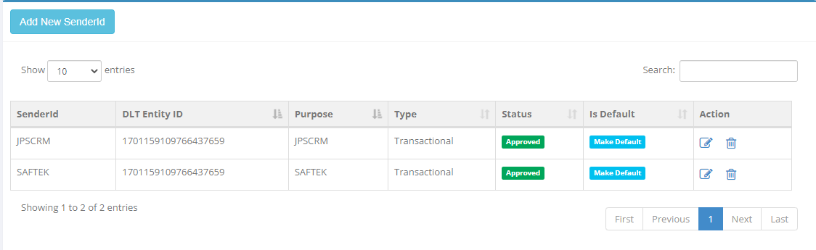

**If there is not any sender id or you want to create new sender id then click “Add New Sender Id” button**

**After Clicking “Add New Sender Id”   
  
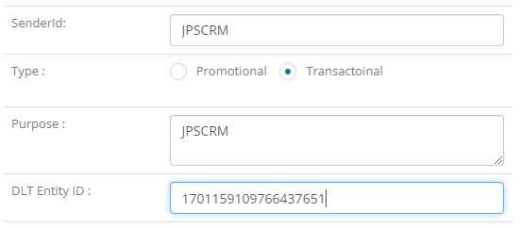**

**Open POP UP for enter sender id like this we have enter this data**

**SenderId : Sender id is our header name which we have created at DLT Panel**

**Type : We have select Transational**

**Purpose : we can give give header name and other text**

**DLT Entity ID : This is in the DLT Panel in the profile page. There will be “Registration ID”. (“Registration ID” is DLT Entity ID)**

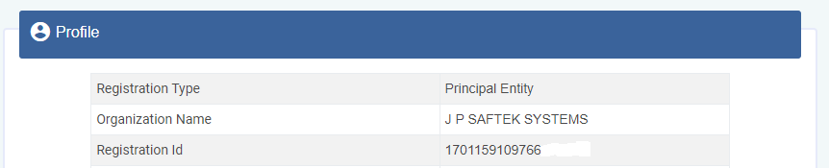

**“Registration ID”. (“Registration ID” is DLT Entity ID). This is available in DLT Panel in profile section**

**After entering all details click submit and wait. It may take some time or not**

**Testing For SMS**

**After setup sender ID We have go to “Text SMS” and then click “Send SMS”**

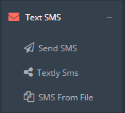

**After Clicking Send SMS We have open a new page like this!**

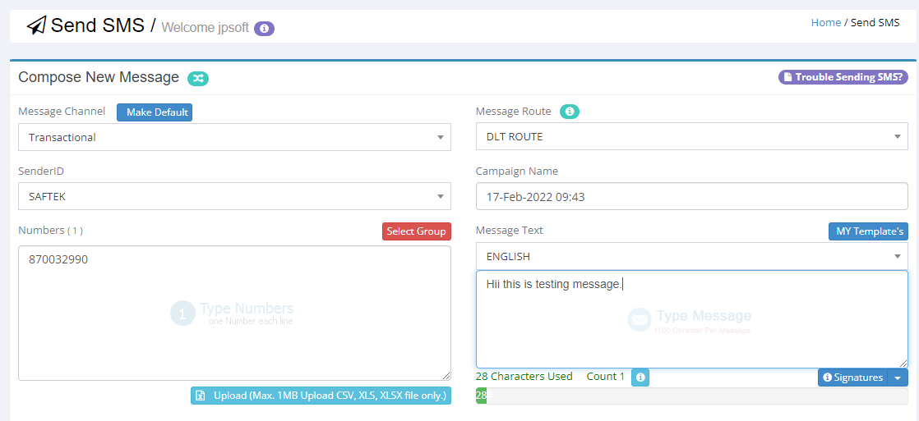

**There are four fields that are more important.**

1. **Sender Id : Select one sender Id which we have created before.**
2. **Numbers : Enter Your Mobile No**
3. **My Template’s : After Click My Template’s. There show all templates which I have created at the DLT Panel. Select any template in this templates.**
4. **Message : Type your text message in below textarea box.**
5. **After fill this form click “Send Now” button.**
6. **After click “Send Now” button there show one pop up there are “Launch Now” button. Click this button. and wait for receiving message on your number**

**API Integration**

**After successfully sent message to your number . next step is API Integration**

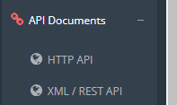

**Click “API Documents” and then “HTTP API”**

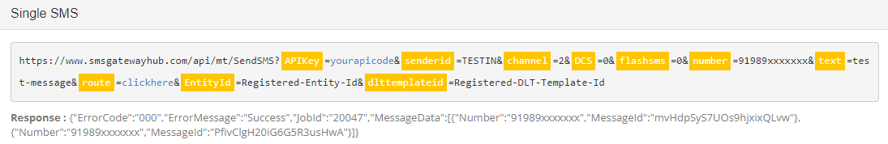

**There are showing this api link.**

**API Key will get after click on . And set all value according this API LINK**

**Note:**

**SMS Gateway Hub Provide Any Desk Support :**

1. **Call No : 9907922122** (Main number)
2. **Vishant : 9111008240**

(Before Taking support from smsgatewayhub Our header and template should be ready from DLT Panel)

**DLT Panel (Smartping)**

1. **Helpline No: 18001370011**